Project Two Status Report – Noah Ford
Foreword
We are making a Discord bot that acts as a means to look at the ETSU CBAT course catalog. We plan for the bot to include ways to search for specific courses, majors, degrees, concentrations, and combinations of the prior. In this project, we require a discord bot frontend, an API backend, and a database to query for information.
This report will cover each persons role in the project, specifics about that role, a breakdown of our project structure, and finally what we have completed and what’s left to do.

Project Members and Roles
Our group for this project consists of five members:
- Noah Ford – Project Lead / Frontend
- Brock Morell – Frontend
- Sydney Gnoth – Backend
- Ashley Johns – Backend
- Olivia Smith – Database

FRONTEND
People working on the frontend are responsible for designing the discord bot user interface, as well handling the interaction between the frontend and our backend API.
Currently the project members assigned to this are Noah Ford and Brock Morell.

BACKEND
People working on the frontend are responsible for designing the API and endpoints that are necessary for the project to function.
Currently the project members assigned to this are Syndey Gnoth and Ashley Johns

DATABASE
People working on the database are responsible for creating as well as populating the database with CBAT catalog information.
Currently the project member assigned to this is Olivia Smith.

Project Structure
Our project is being hosted on a shared GitHub repository that each member will contribute to.
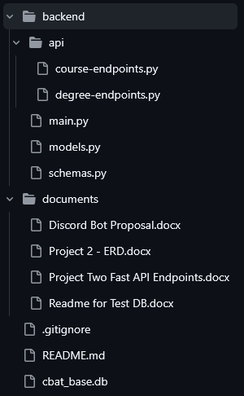
File Structure
Frontend and Discord bot related files are kept within frontend (not shown).
Backend and API related files are kept within backend

We also store any project related documents and documentation within documents

Our database, README, and gitignore are all kept within the root of our repository

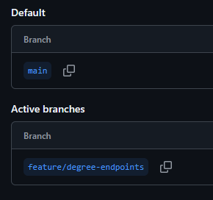
Branches
We are also developing with branches, isolating specific features to a branch, that once completed will be merged into our main branch.

We do this avoid merge conflicts and keep an organized structure with multiple people collaborating on a single project.

Our Progress
We have made steady progress so far, having solid work on our database and our backend API.

Olivia has been working consistently designing and populating the database for our project, as well as consistently updating it and keeping it fresh on the repository.

We decided to split our API into two “Endpoint Groups” for people to work on, being taken up by Sydney and Ashley. Our API development is almost done, we just have a little bit more to complete as far as endpoints and developing our entry point.

Our plans going forward are to begin work and research on developing our frontend, being the Discord Bot. We have already created an application via Discord Developer’s Tools and will be starting on this soon.

